When there are unfinished activity work issues related to Rental transactions that have not been invoiced, it is exactly that.
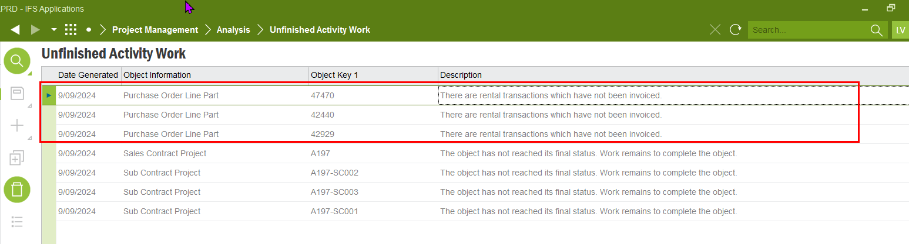
To find these invoices follow to procedure below.
Check for invoices. Go to the purchase order. RMB on the rental line and select Rental Workbench
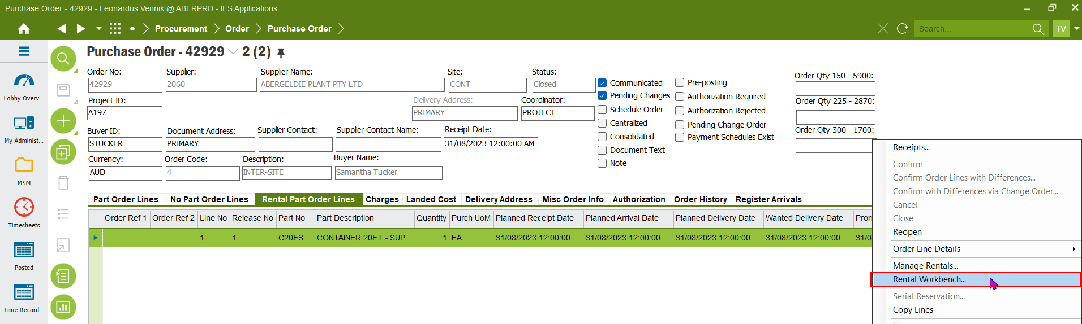
In the Rental Workbench go to ‘Linked Rental Lines’, RMB on the Customer Order line and select Rental Workbench
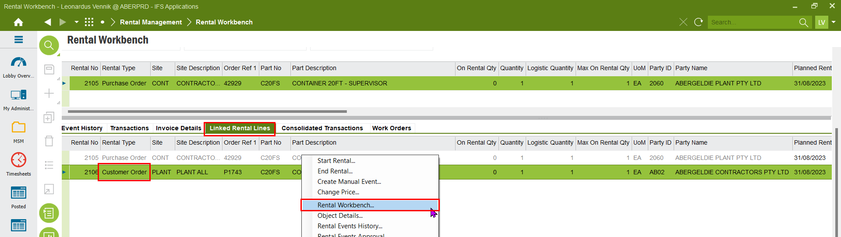

In the Invoice Details tab of the Customer Order Workbench, check the invoice status of all the customer invoices. Must likely there is an invoice created, but not posted.
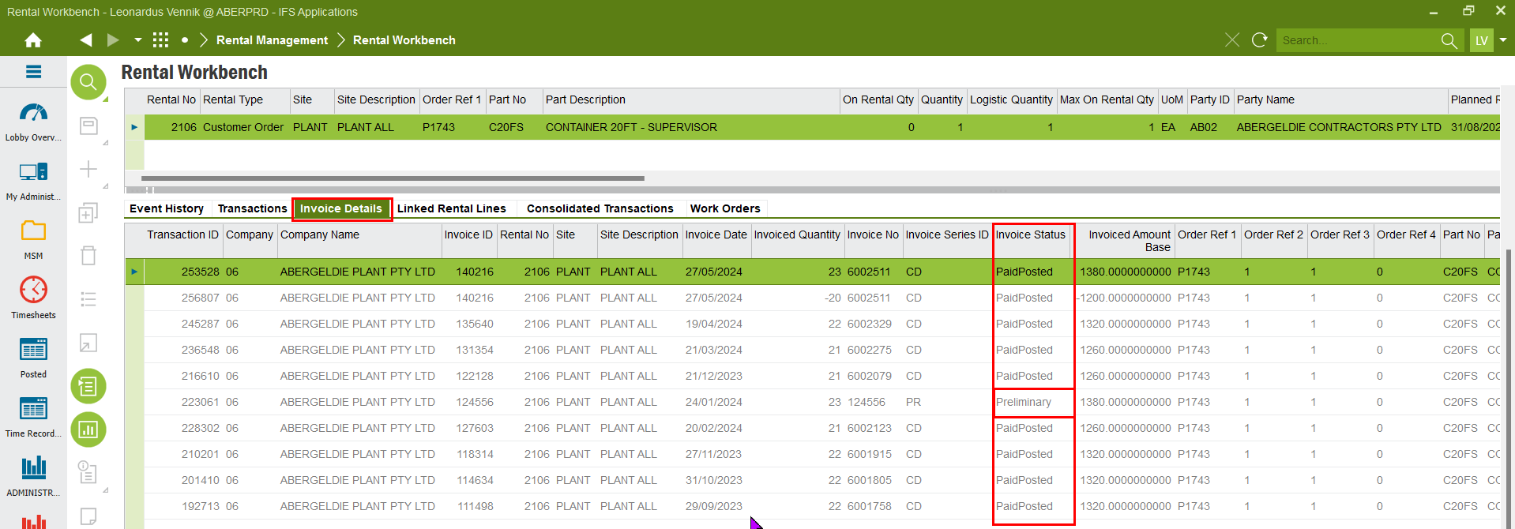
RMB on the preliminary invoice line and select Customer Invoice
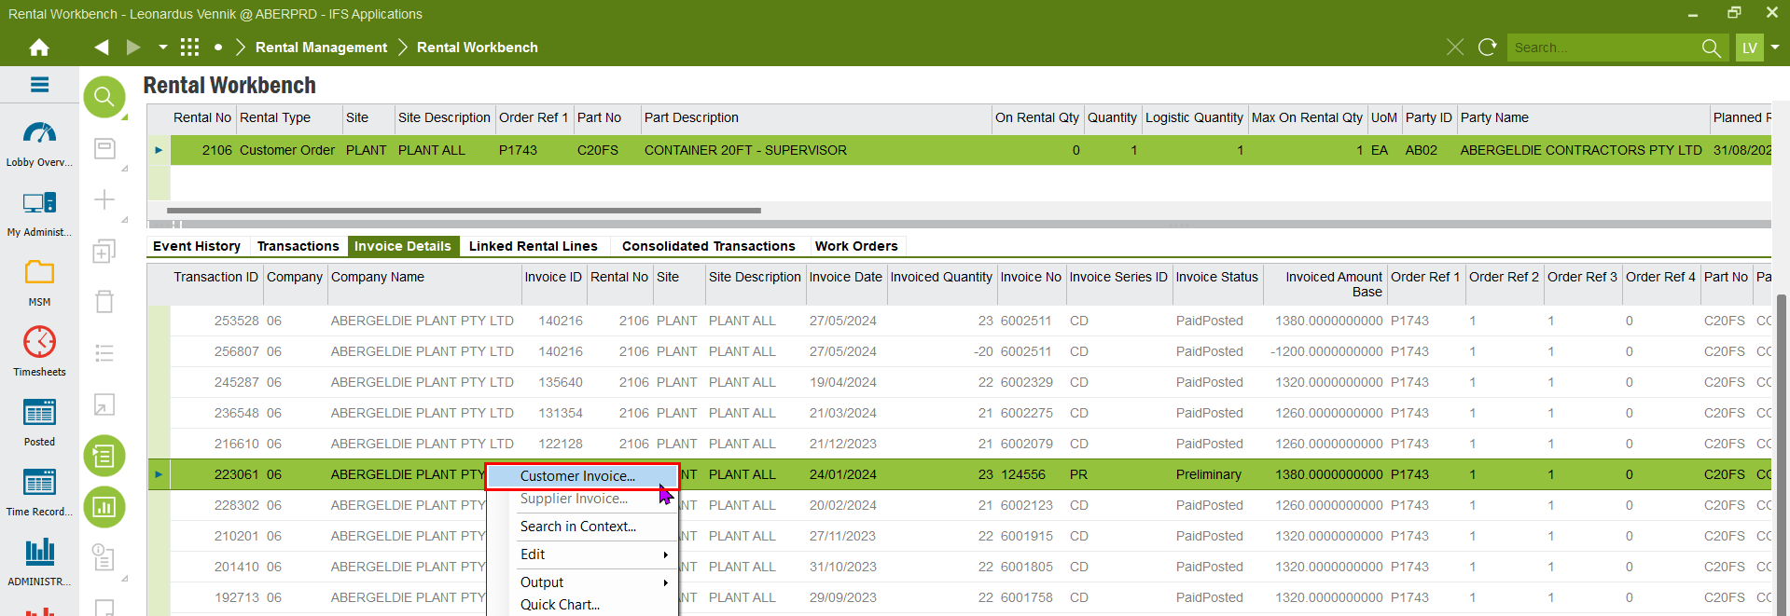
In the Customer Invoice complete the state legislation, set the invoice date to today and save the invoice
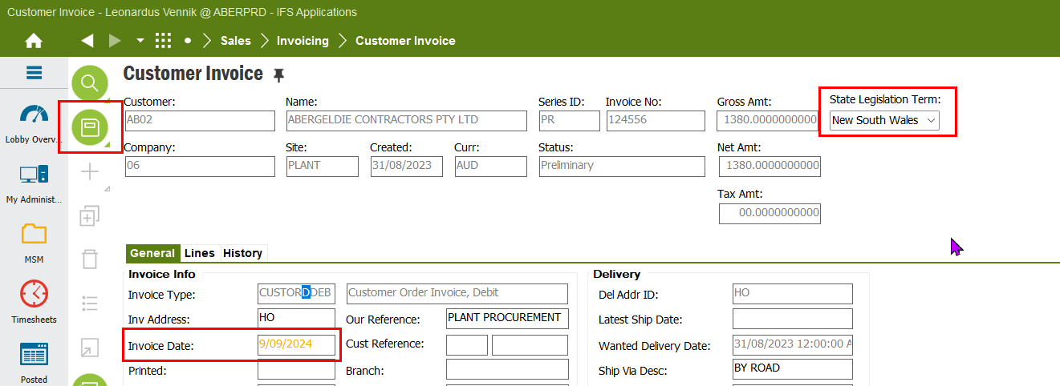
RMB in the header and Print Invoice
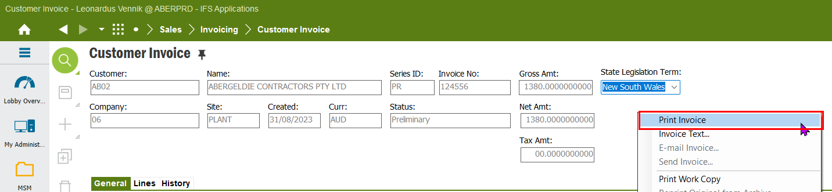
Click OK
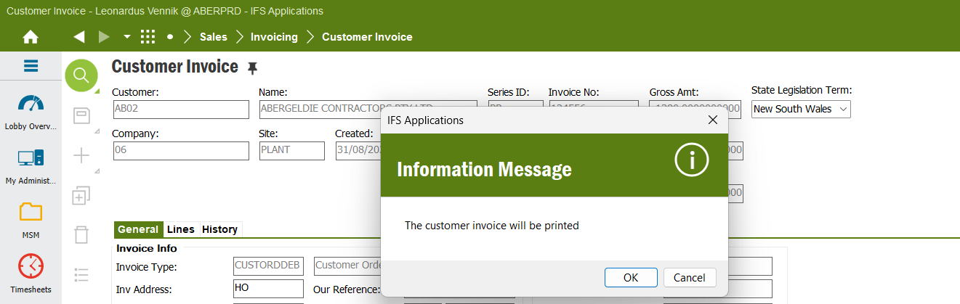
Send the invoice to invoices@abergeldie.com
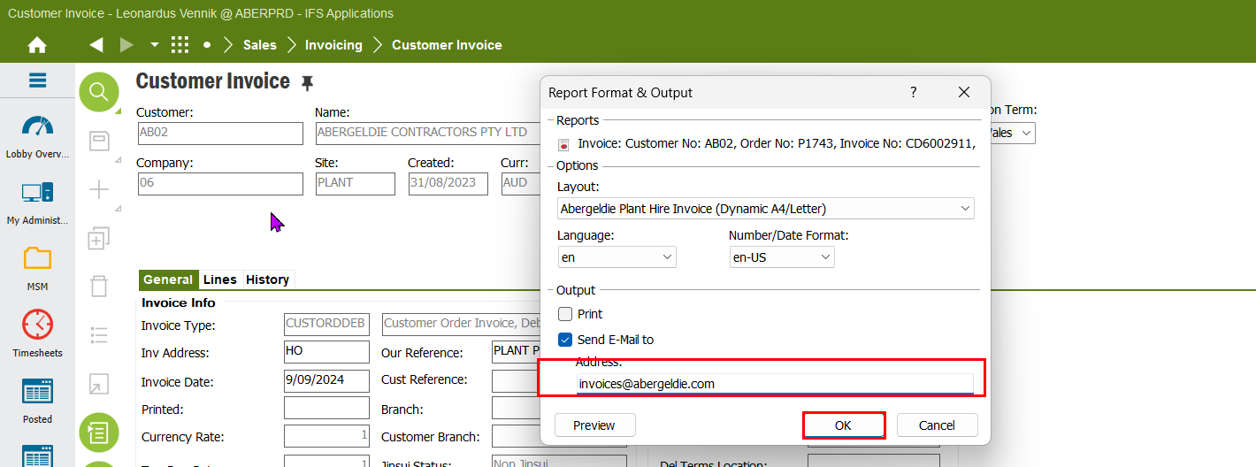
The invoice is now send and will be managed via ABBYY. It will take some time before the invoice is created in IFS. Once the invoice is created, the AP department will process the invoice. When the invoice is completely processed and the GL is updated, the unfinished activity work for the project can be completed.

