Change order for Rentals
This document provides a step-by-step guide on how to create a purchase order change order for rental items
General Note  When an active rental needs to be extended, a purchase order change order must be sent to the plant department. To do this, follow these steps:  - Navigate to the purchase order for the rental item.  - Reopen the rental line | 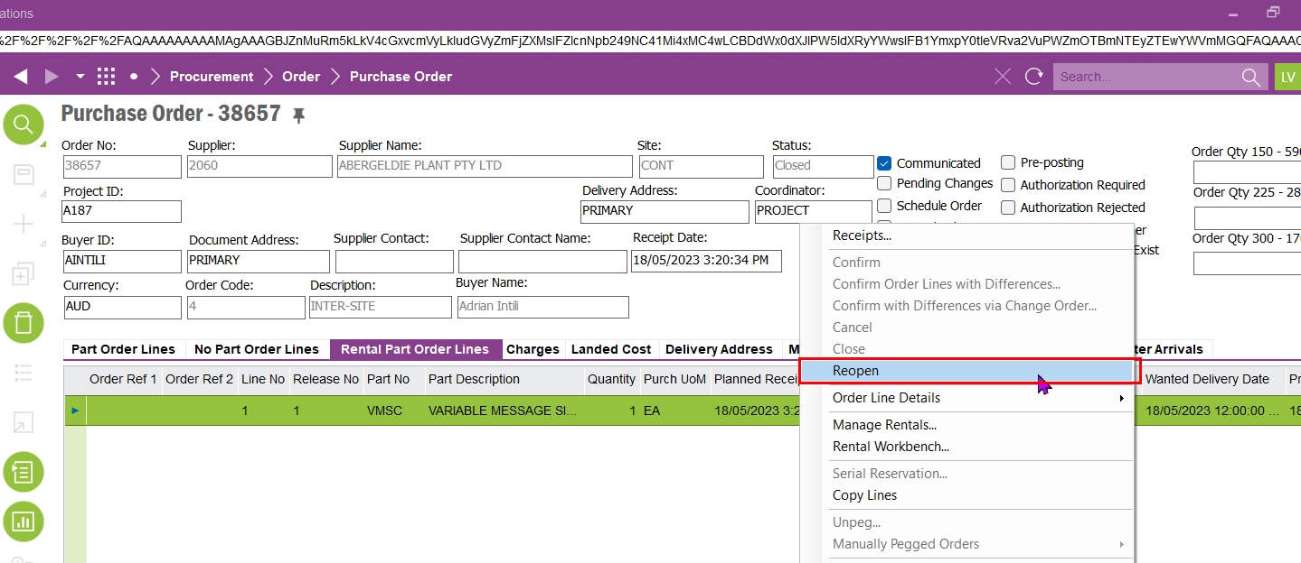
STEP 1  Create a change order for the purchase order by selecting the appropriate purchase order and initiating the change order process. Ensure that all necessary adjustments, such as extended rental dates or updated quantities, are accurately reflected in the order before submitting | 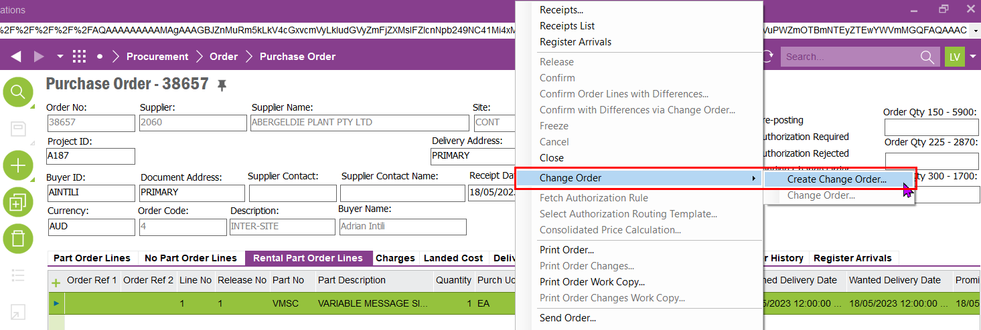
STEP 2  Duplicate the rental line in the change order by copying the existing rental line and adding it to the change order. Ensure that all relevant details, such as rental duration and item specifications, are correctly carried over to reflect the updated requirements | 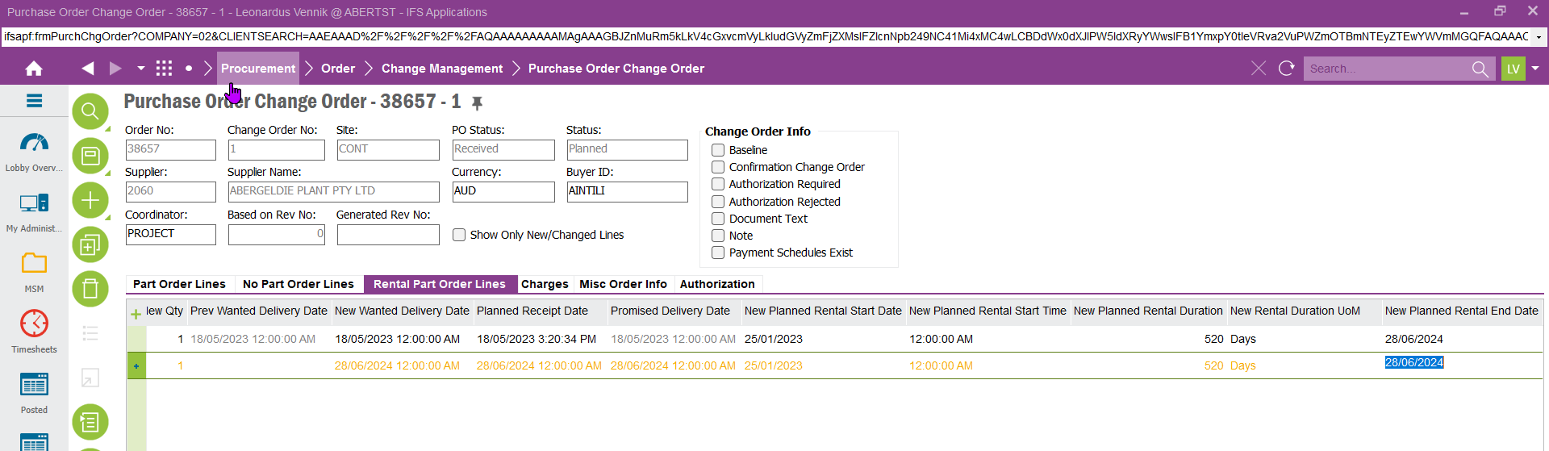
STEP 3  Set a new rental start date, ensuring it is the day immediately following the rental end date from the previous line. Then, enter the new rental end date based on the extended rental period | 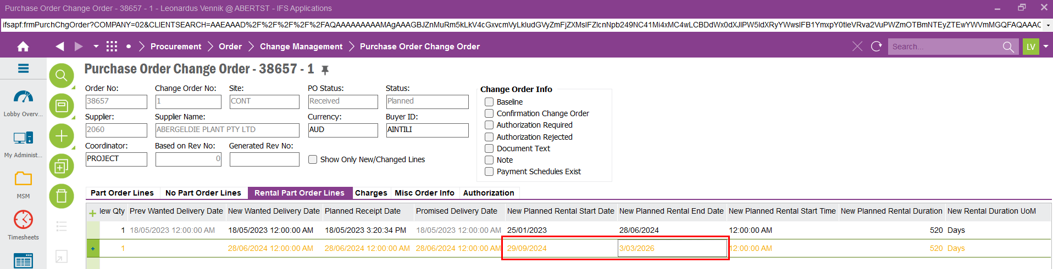
STEP 4  Enter the correct rental prices for the extended period. If unsure, double-check the pricing details with the plant department to ensure accuracy before proceeding | 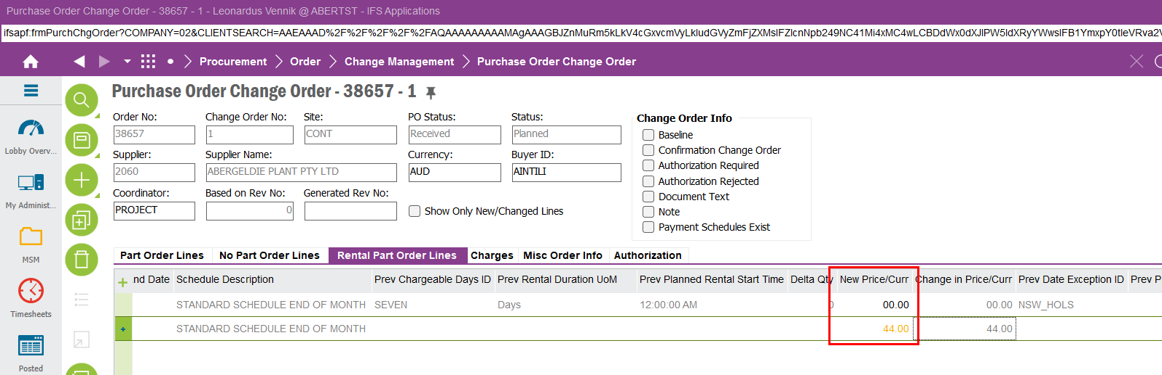
STEP 5  Link the rental line to the appropriate project activity to ensure accurate tracking and allocation. Verify that the connection reflects the correct project and activity details before finalizing | 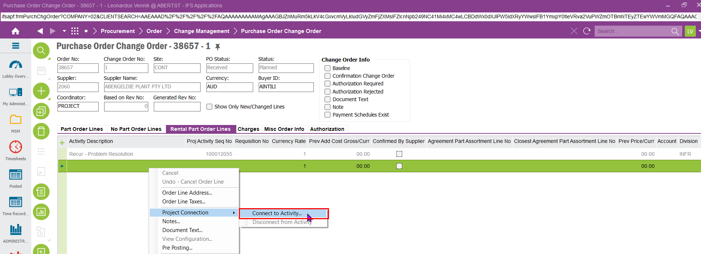
STEP 6  Input the relevant project details in the dialog box, ensuring all required fields are accurately completed. Double-check that the information aligns with the project specifications before confirming | 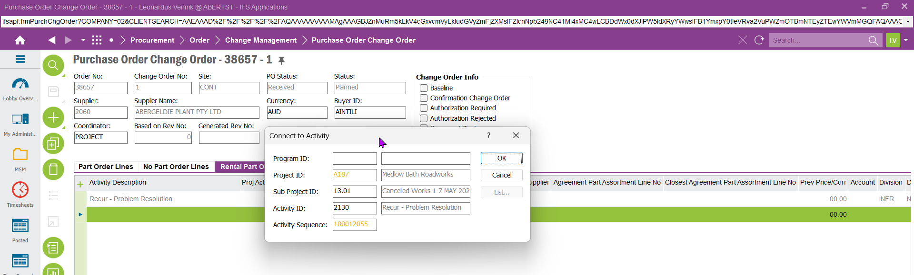
STEP 7  Release the change order | 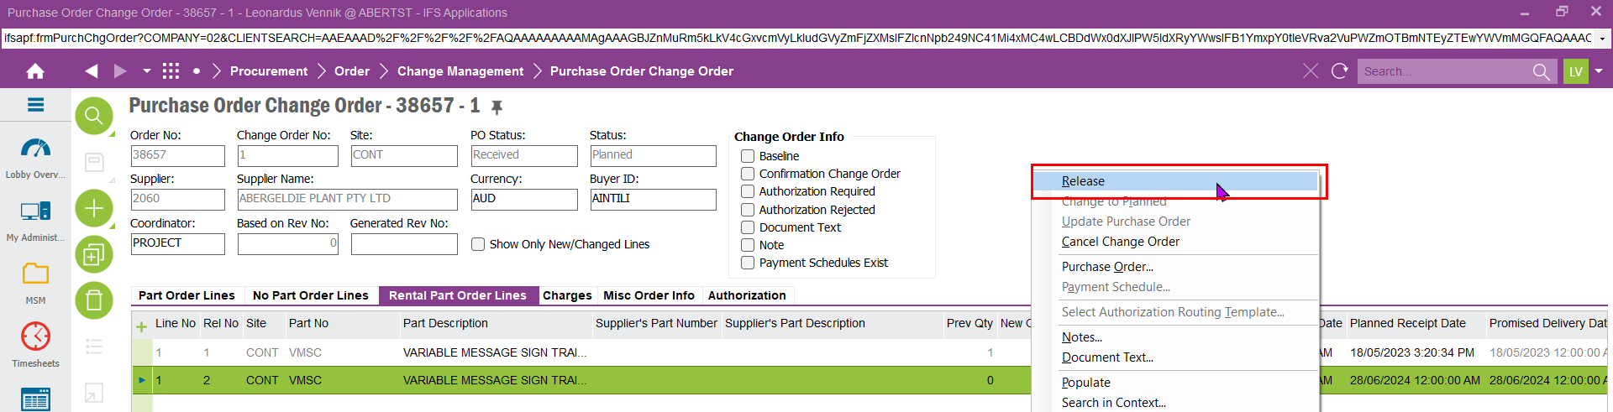
STEP 8ssssdssd  The change order must be authorized before it can be processed. Ensure that the necessary approvals are obtained from the appropriate department or personnel to finalize the order. | 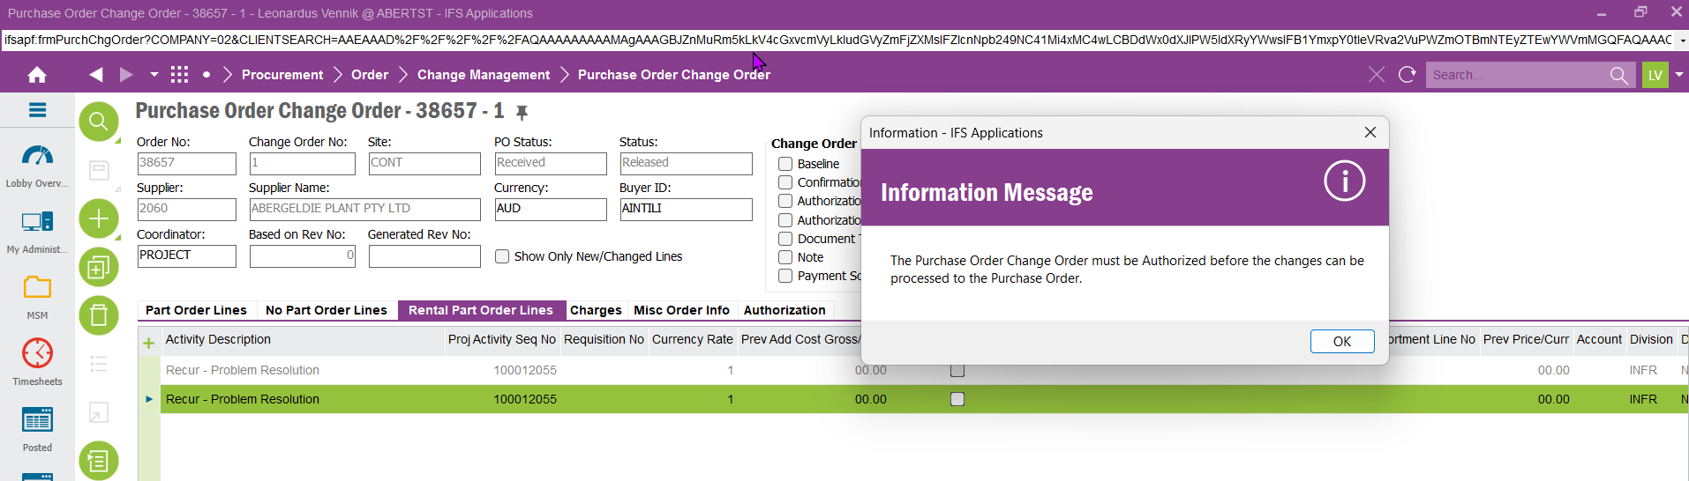
STEP 9  Authorize the PO | 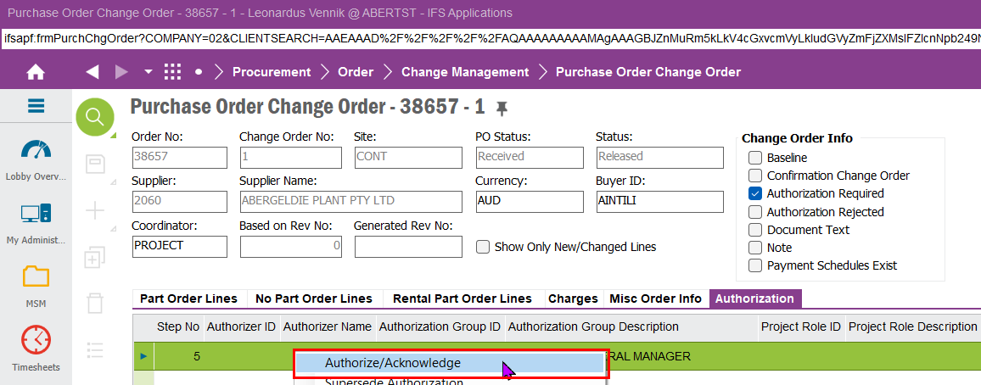
STEP 10  Update the purchase order (PO) to reflect the changes made in the PO change order. Ensure all modifications are accurately applied before saving and finalizing the updated PO. | 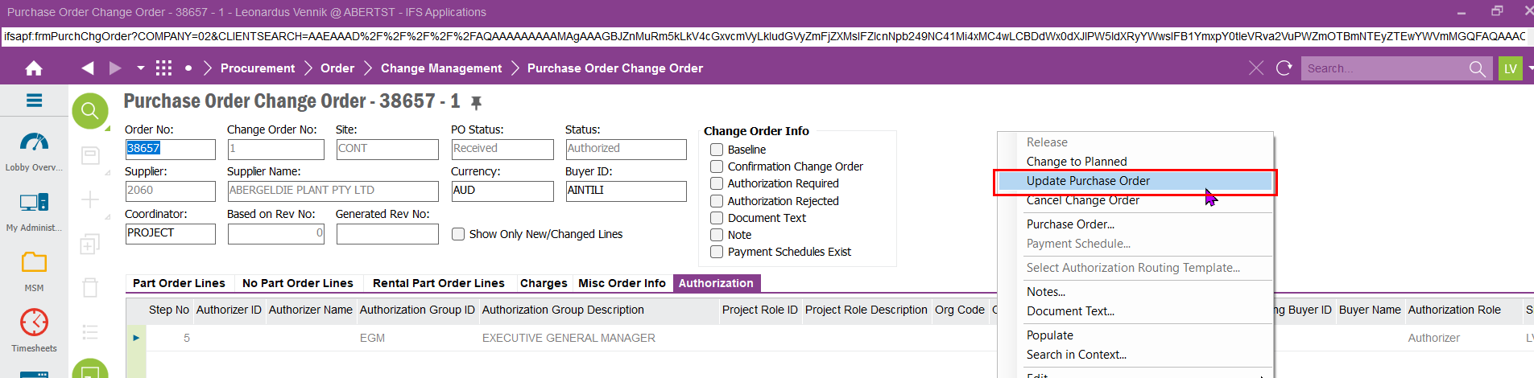
STEP 11  Submit the change request to the Plant Department for review and approval. Ensure that all relevant details are included to facilitate a smooth processing of the request | 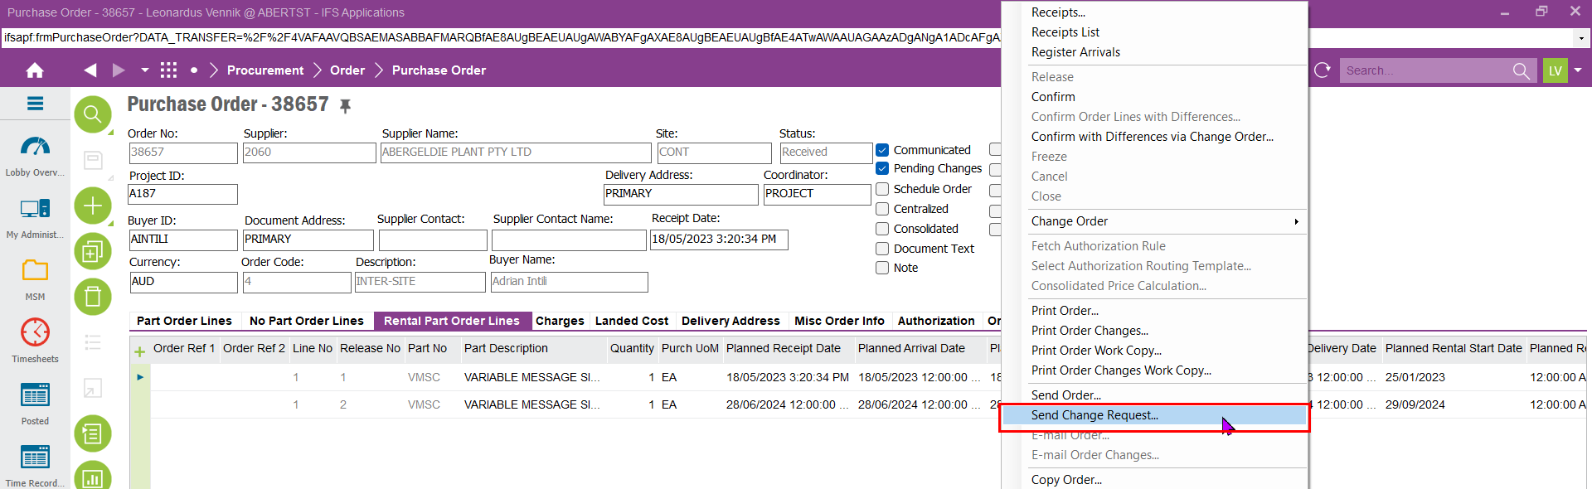
STEP 12  Click on the list button to select the correct Media Code | 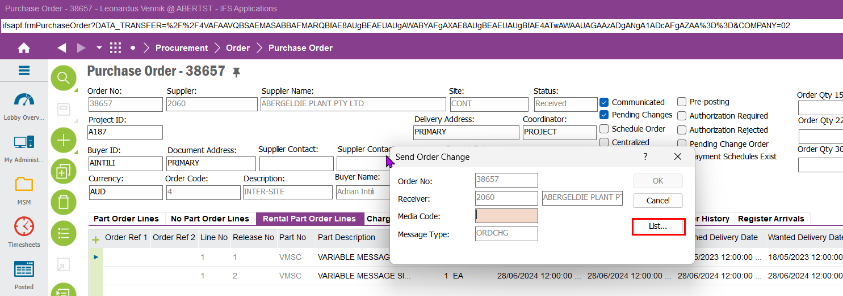
STEP 13  Select MHS as Media Code | 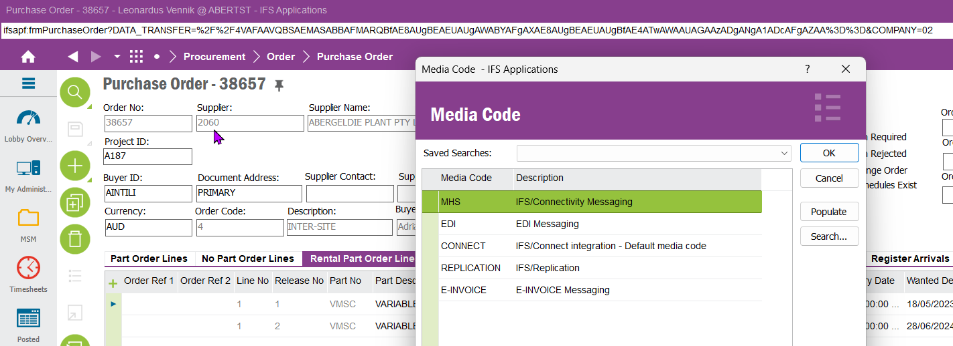
STEP 14  Click 'OK' to finalize the process. The change order will be sent to the Plant Department, where it can be reviewed and processed for the new rental period. | 