Resolving Stuck Rental Purchase Orders
This document provides a step-by-step guide on how to create a purchase order change order for rental items
General Note  When a rental purchase order (PO) is not received, but a customer return material order has been created to return the rental item to stock, the PO remains in a "Released" status. It cannot be received because the rental serial part has already been returned to inventory, and in most cases, rented out again. This creates a situation where the PO is stuck: it cannot be received, cancelled, or closed due to its connection to a rental, and because rental periods are still associated with it.  To overcome this issue, it is required to disconnect the PO rental line from the rental periods by removing the rental periods in the rental workbench. This can be achieved by reversing the rental start and rental end dates. | 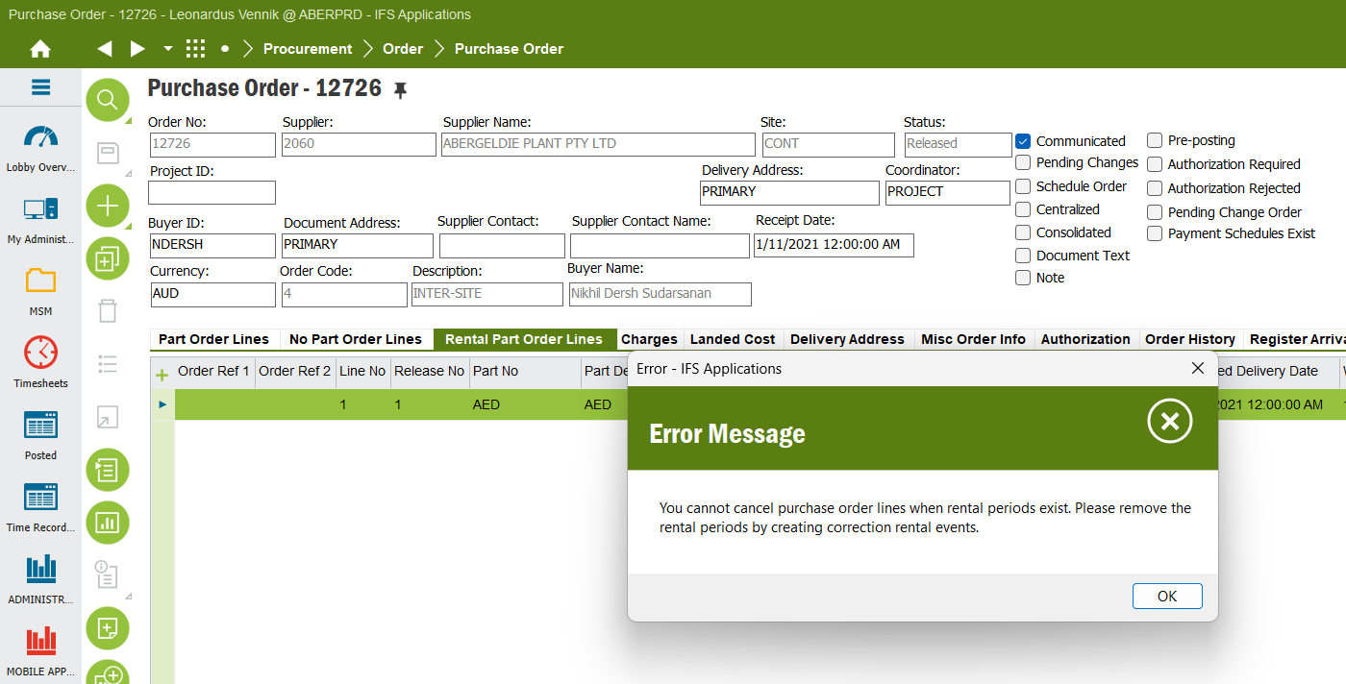
STEP 1  Steps to Resolve the Issue:  - Access the rental purchase order (PO) in question.  - Right-click (RMB) on the specific rental PO line where the issue exists.  - Navigate to the Rental Workbench. | 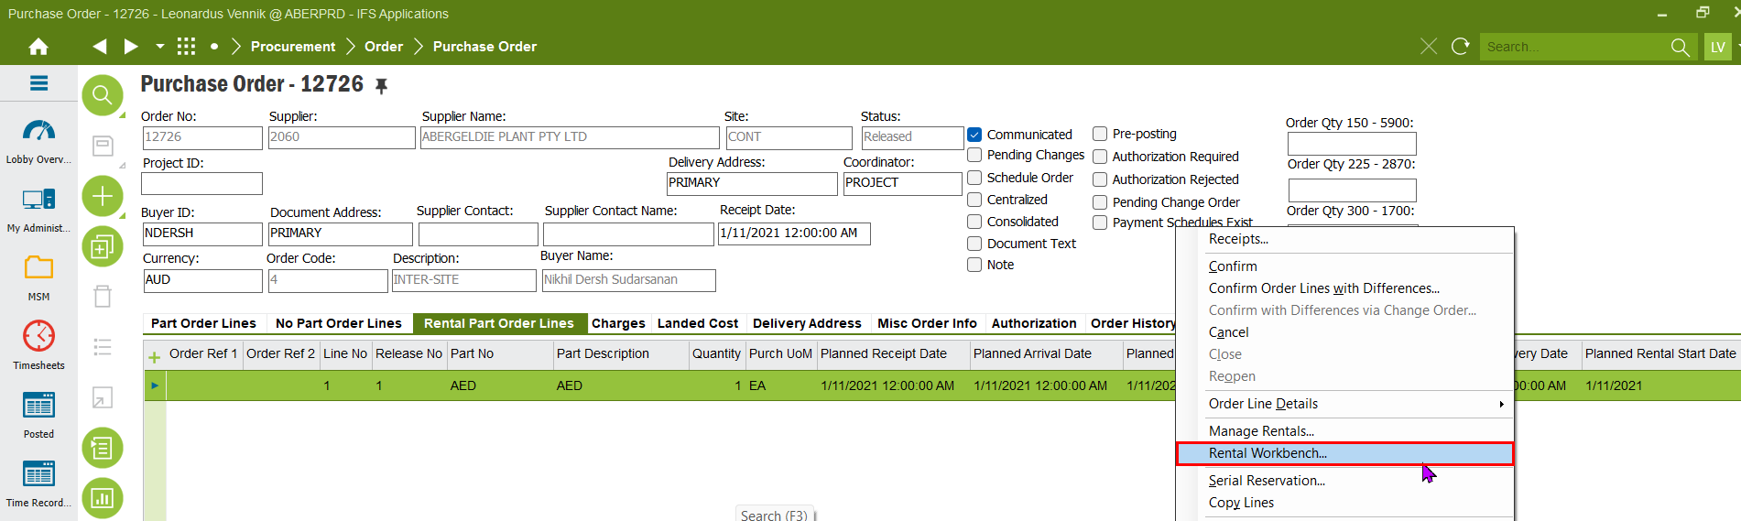
STEP 2  In the Rental Workbench, navigate to the Linked Rental Lines tab at the bottom of the page. Right-click (RMB) on the customer order rental line and select Rental Workbench. | 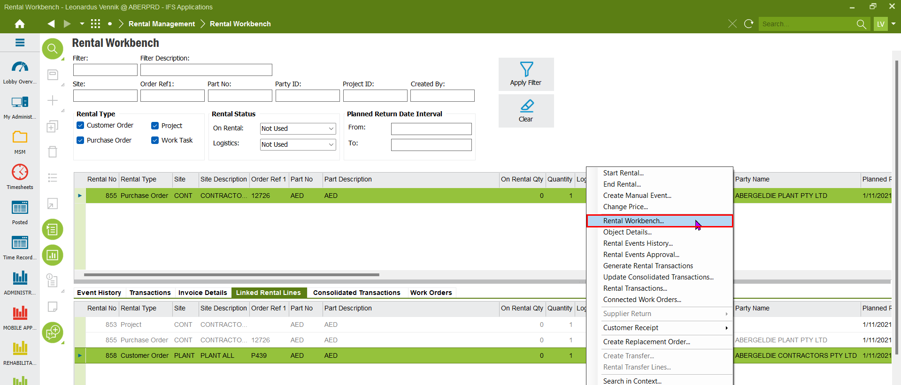
STEP 3  In the Event History tab, check the rental end date. Use this date and time to start the rental. | 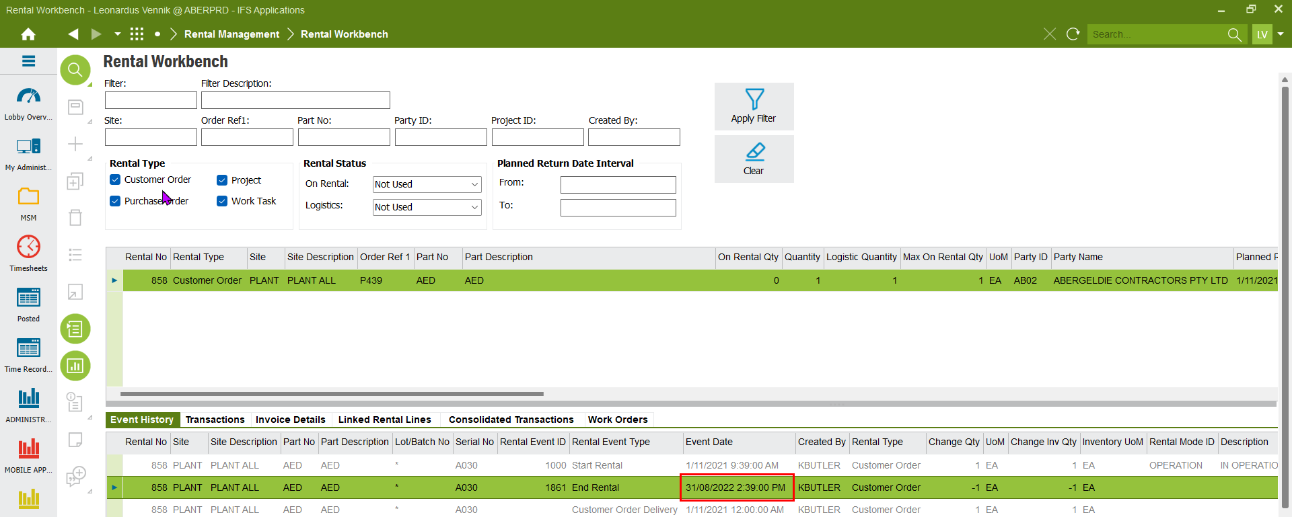
STEP 4  Right-click (RMB) on the customer order rental line and select Start Rental. | 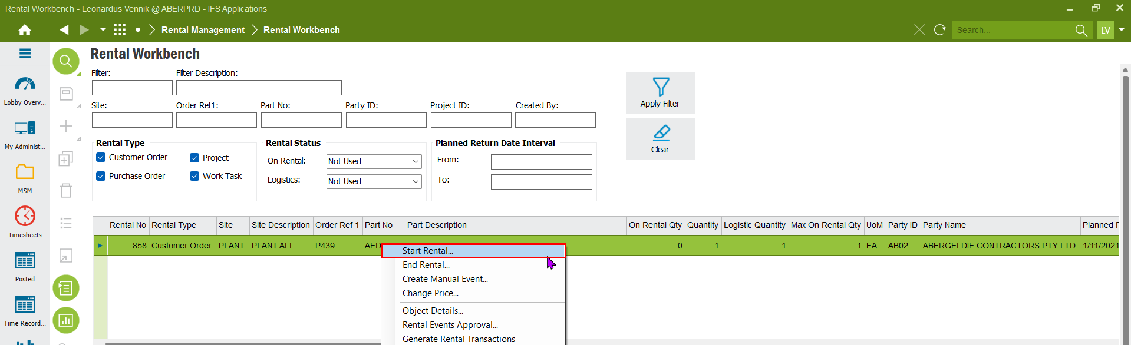
STEP 5  Enter the rental end date and time to initiate the rental. Put in a quantity of 1  Click OK | 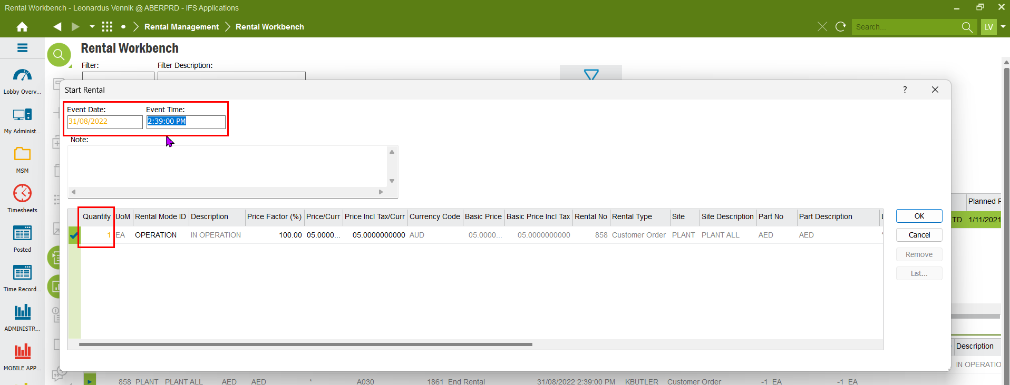
STEP 6  In the Event History tab, check the rental start date. Use this date and time to end the rental. | 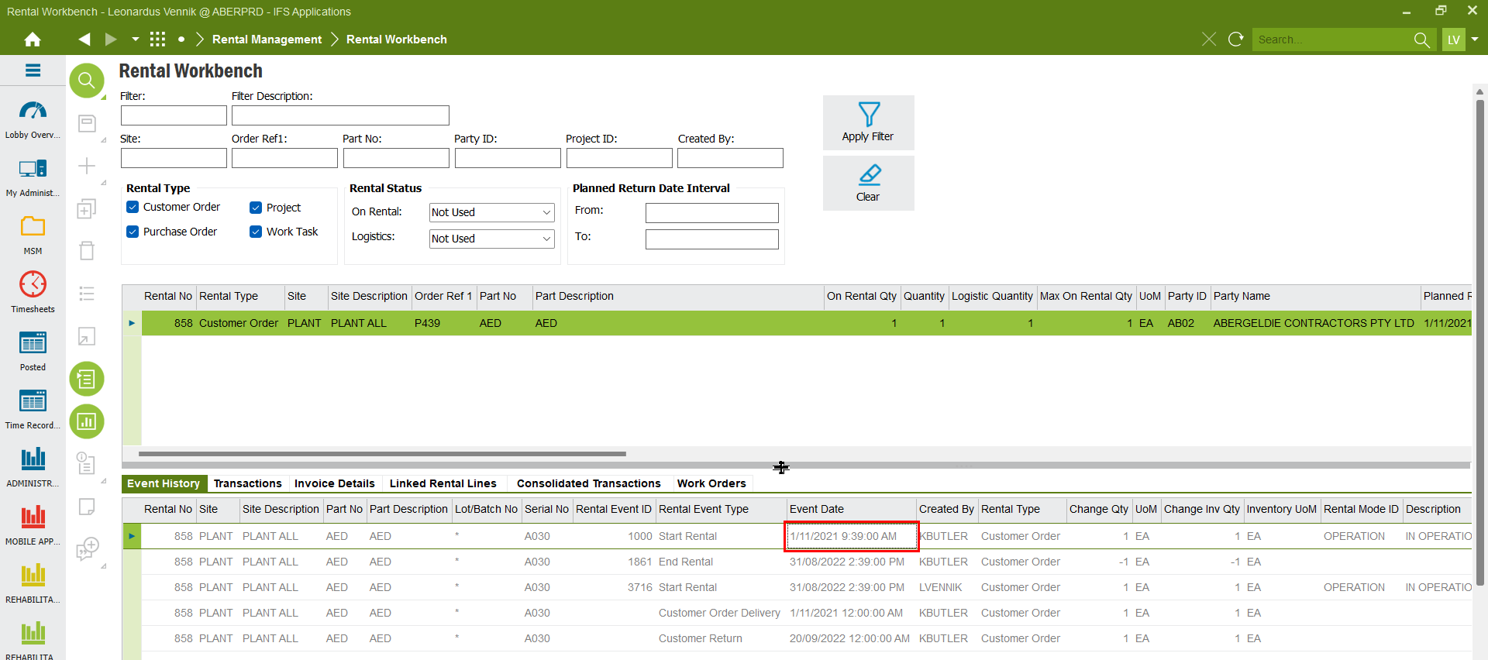
STEP 7  Right-click (RMB) on the customer order rental line and select End Rental. | 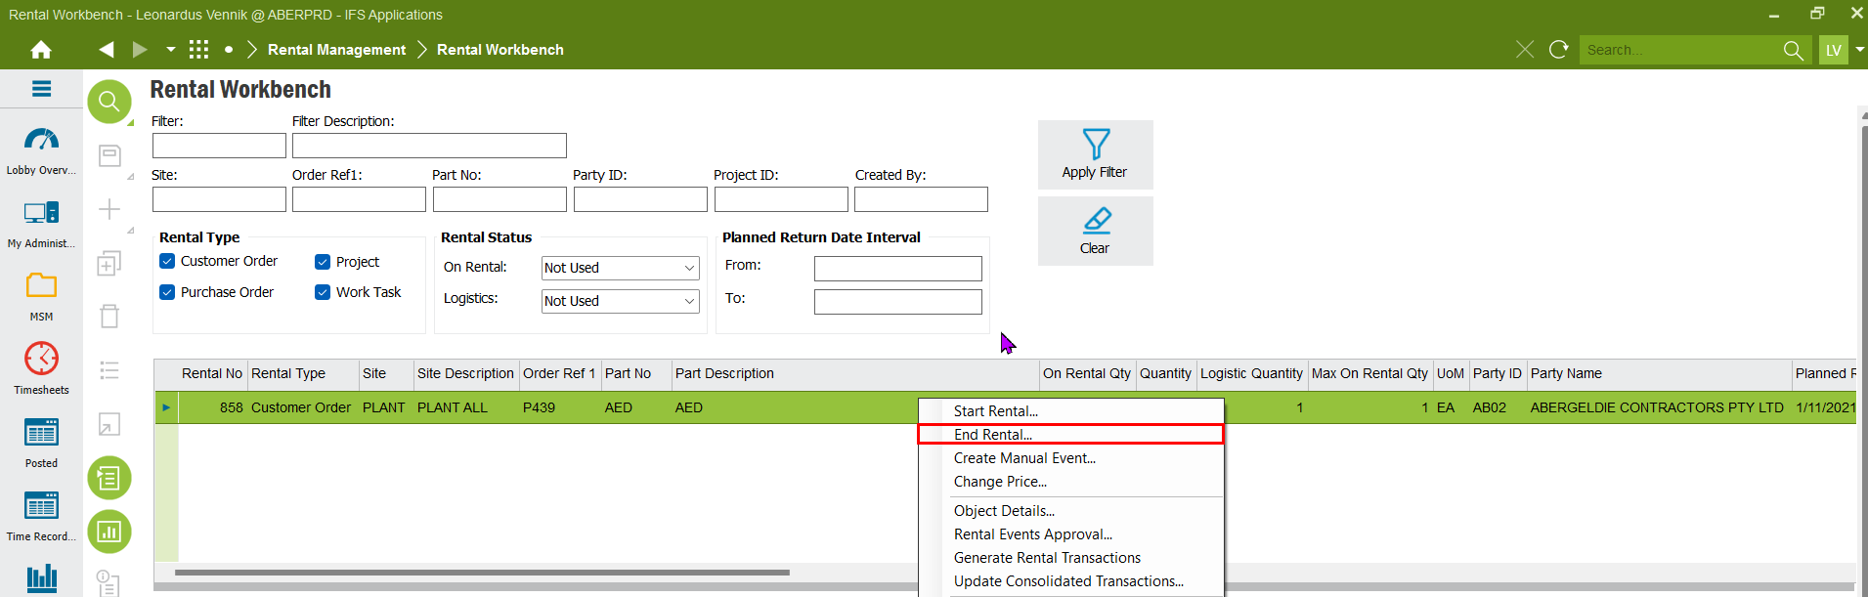
STEP 8  Enter the rental start date and time as rental end date and time and a quantity of 1 to complete the process. | 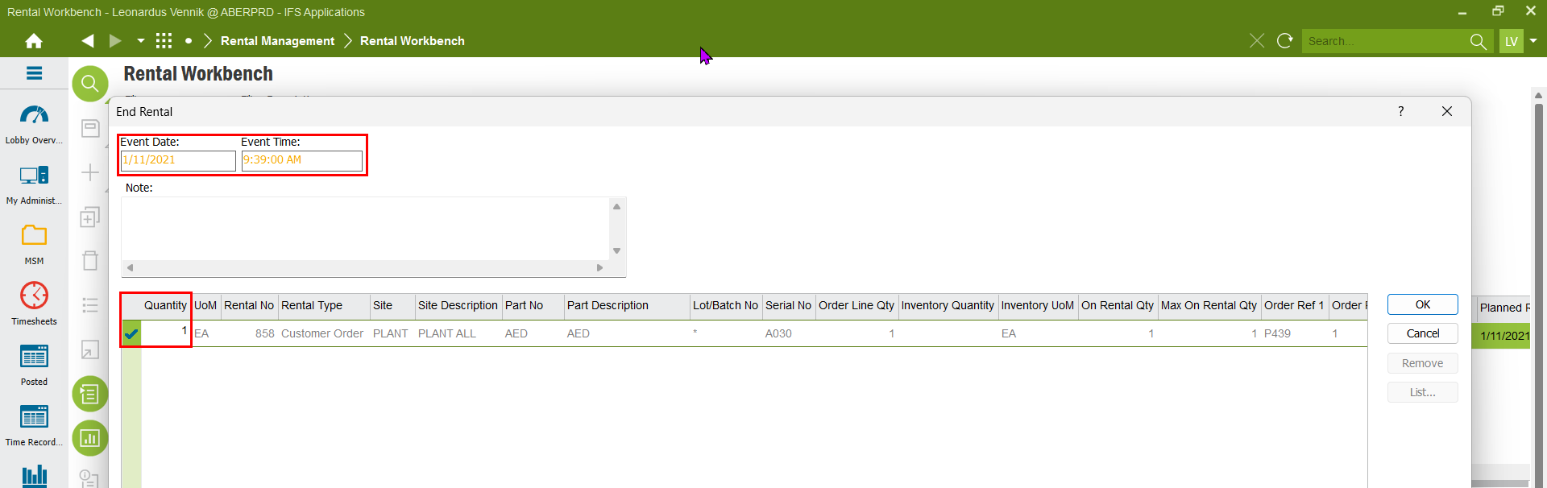
STEP 9  This action reverses the rental periods, allowing the purchase order (PO) to be cancelled.  Check for the project activity sequence number in the purchase order line. Note this down, as you may have to close of the purchase requisition in the activity if the rental request has been created from the activity. | 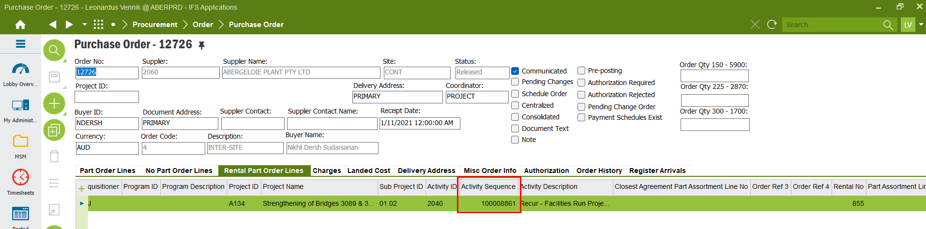
STEP 10  RMB in the PO header and click cancel | 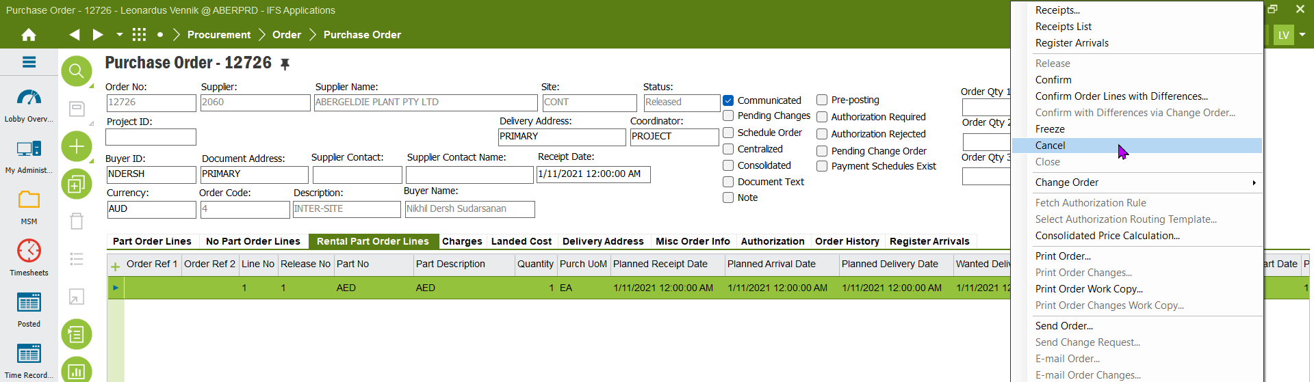
STEP 11  Put the cursor in the Cancellation Reason field and click on List.  Select the REN reason and click OK | 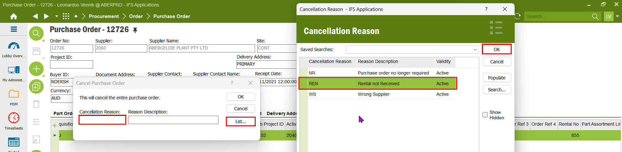
STEP 12  Click OK for this message. | 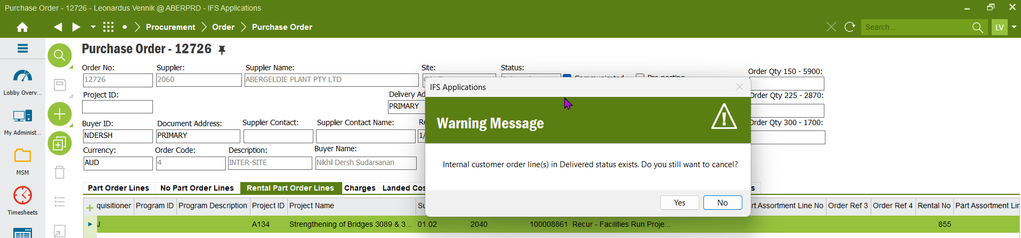
STEP 13  If this message pops up, the associated purchase requisition on the project activity has to be cancelled. Use the project activity sequence ID to access the activity and close off the PR | 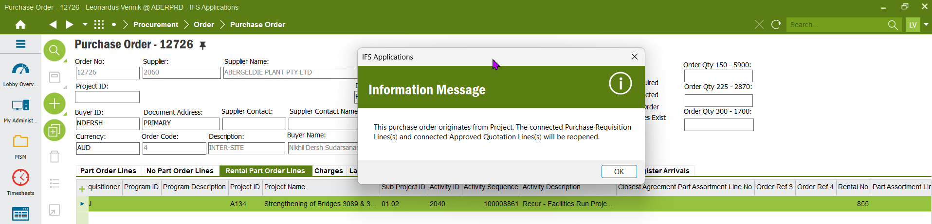
STEP 14  Click 'OK' to finalize the process | 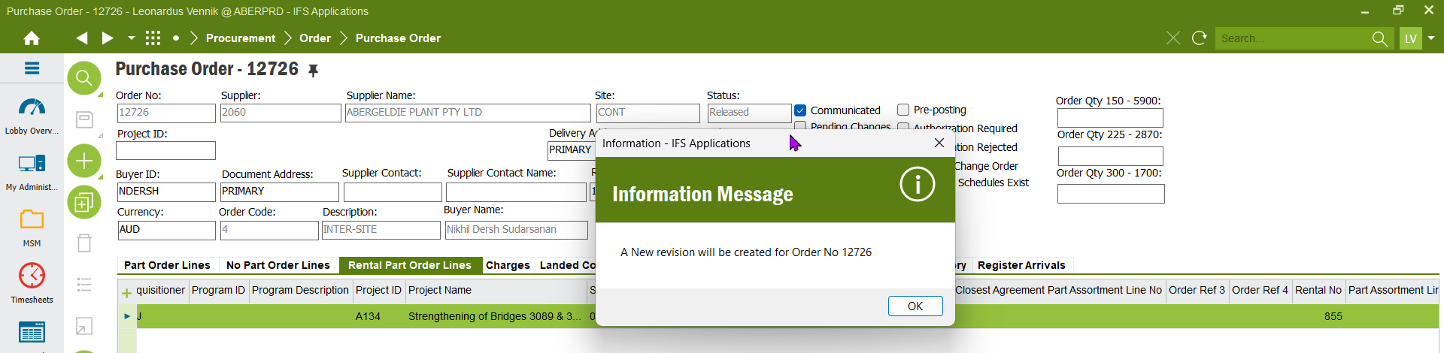
STEP 14  The PO is now cancelled and the process is completed.  Do not forget to close off the PR in the activity. | 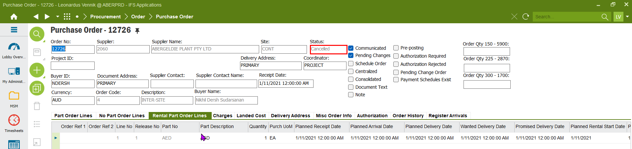
STEP 15 (Optional)  If the rental demand was initiated from the project activity, the PR lines needs to be closed off | 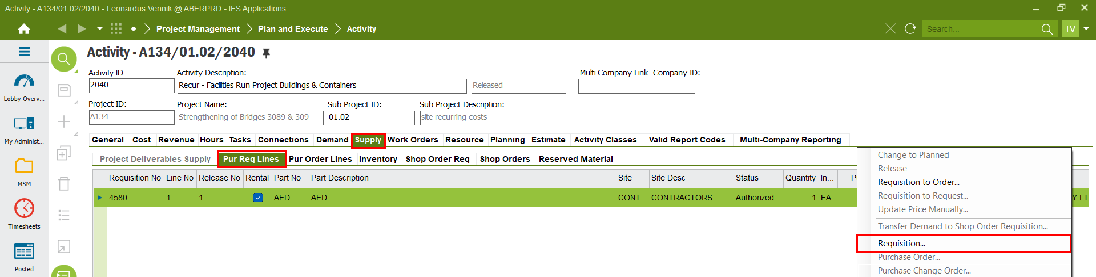
STEP 16  Navigate to the demand tab and then Misc Rental Parts. RMB on the line and Cancel Project Supply Request. | 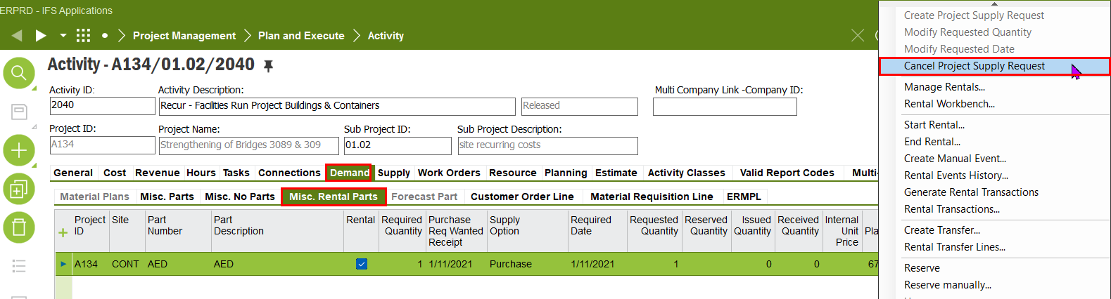
Closed  The PR lines are now removed and the process is completed | 