.
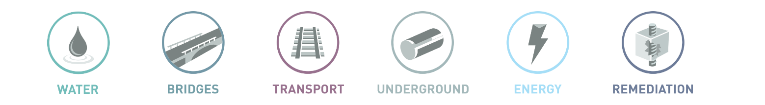

Resolve Outstanding Plant Invoices

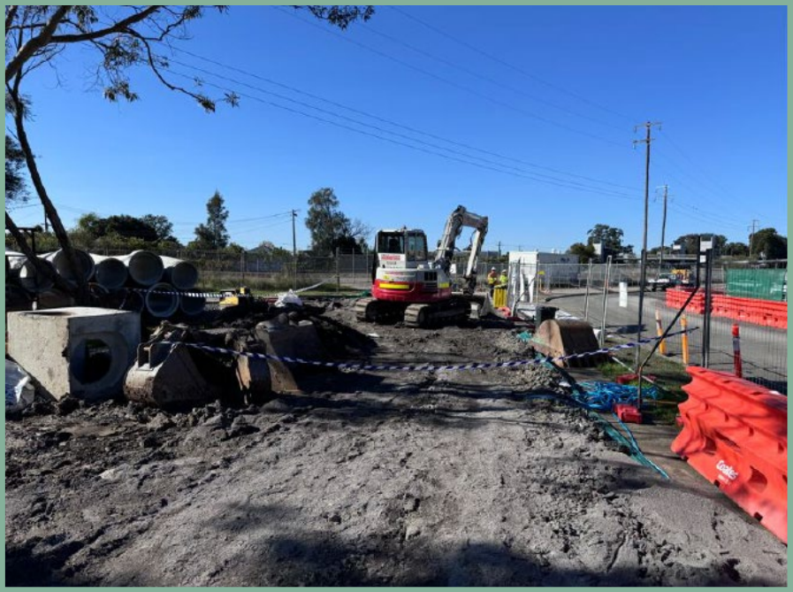
The issue concerns invoices that were created for old rental transactions, which no longer need to be charged to Company 02 due to their age. To resolve this issue, the following steps will be undertaken:

- Credit the Old Invoices:
The Plant department will issue credit invoices to reverse the charges on these outdated transactions.

- Offset Credit and Debit Invoices:
Once the credit invoices have been issued, the Plant Finance Manager will offset them against the corresponding debit invoices, effectively resolving the outstanding balances.

- Cancel and Delete Supplier Invoices:
The AP Officer will:
  - Cancel the manual supplier invoices associated with these transactions.
  - Delete the invoices from the Multi-Company External Invoices View in IFS to ensure accurate records.

Detailed Steps in IFS

Create Credit Invoice for outstanding customer invoices. Open up create credit invoices window and search for the invoice
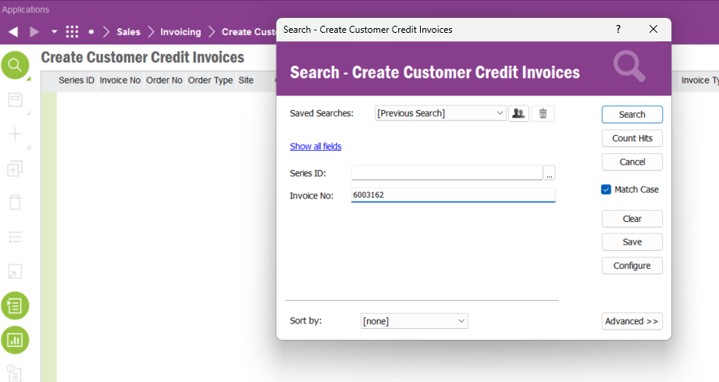
RMB and click ‘Create Credit Invoice’
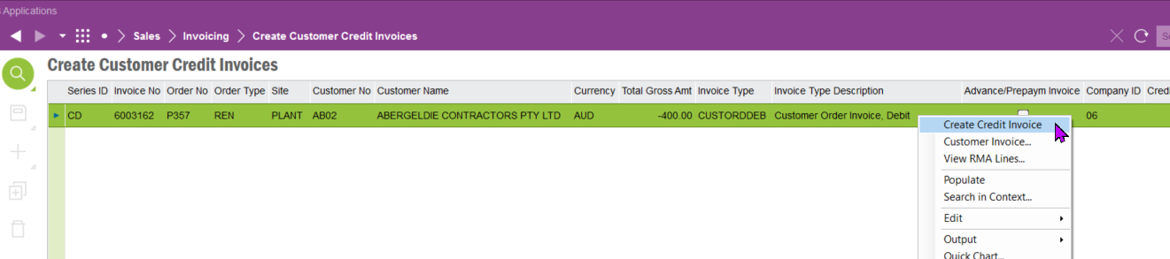

Go to Print Invoice and print the invoice
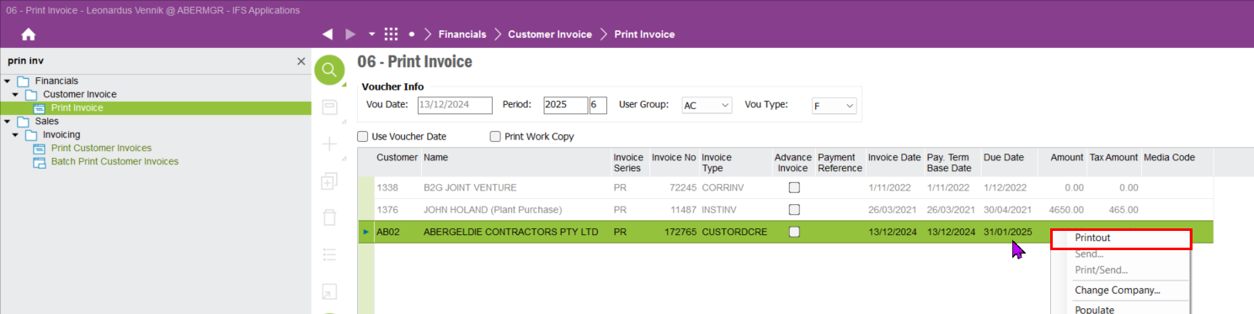

Send the invoice or cancel. Effect is the same

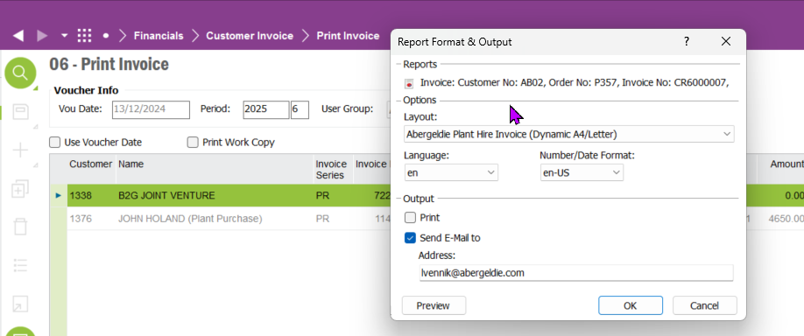

Finance off set customer invoices

AR/AP officer to offset outstanding invoice with the credit one
- Go to Customer Offset and create a new offset form 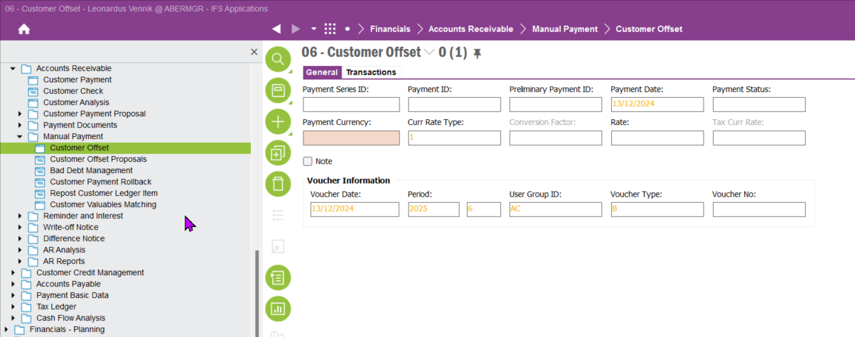cation.

- Enter the two invoices
- 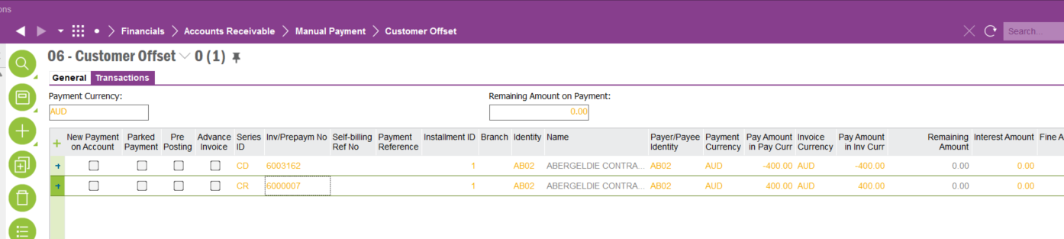
- Approve the offsetted invoices
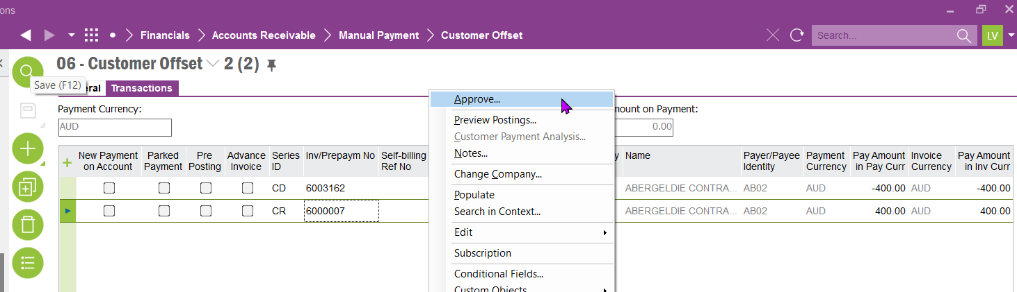

Phase 3: Integration and Testing
- Click OK
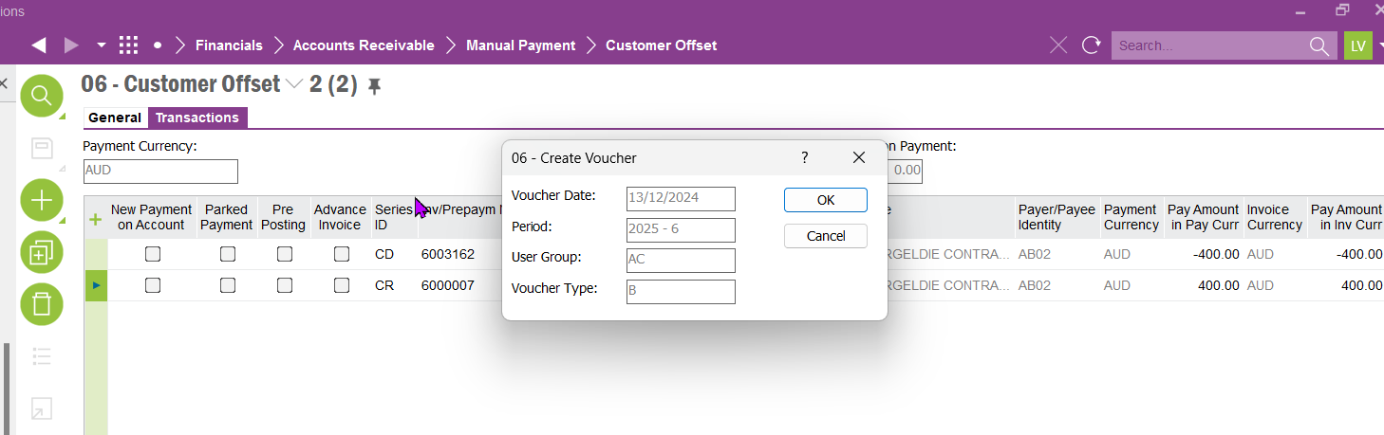
- Click OK

- 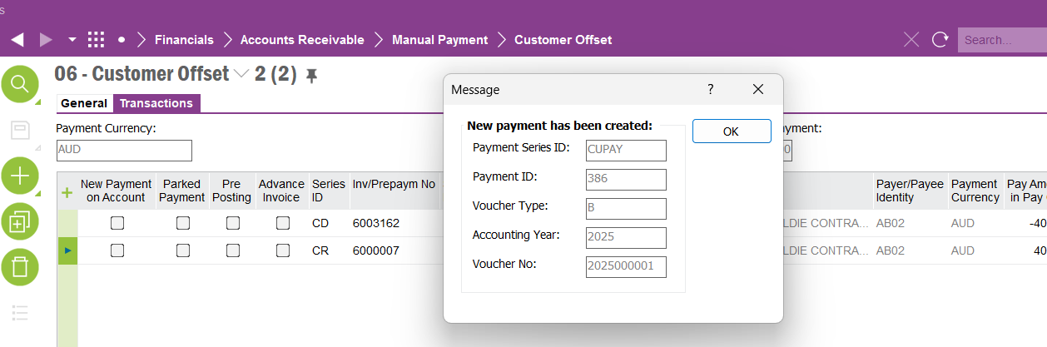8
- The invoices are now resolved. No more outstanding invoice

AP Cancel Supplier Invoices

Go to Manual Supplier Invoice and query for the invoice
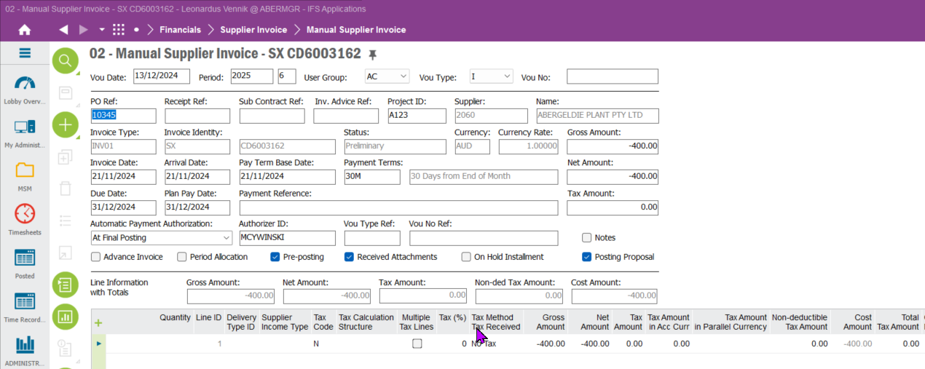

RMB in the header and Cancel the invoice
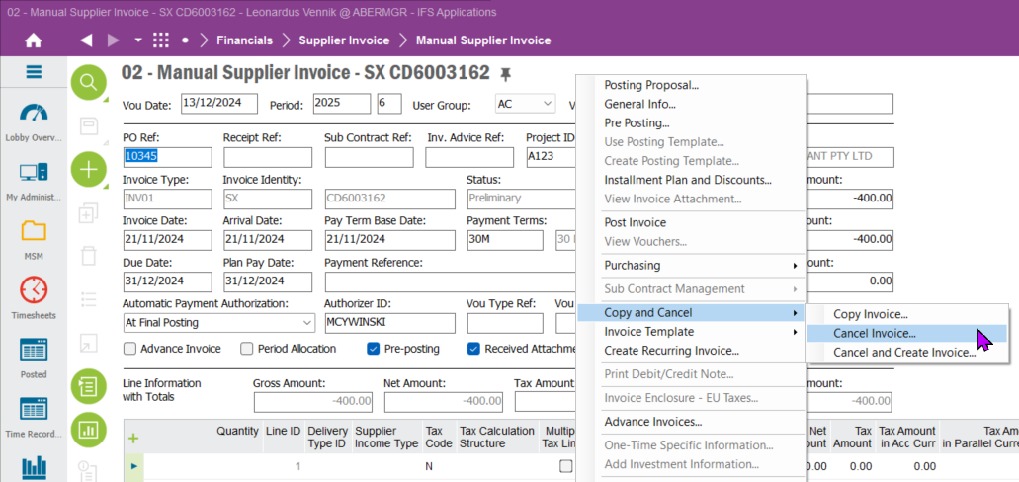

Click OK

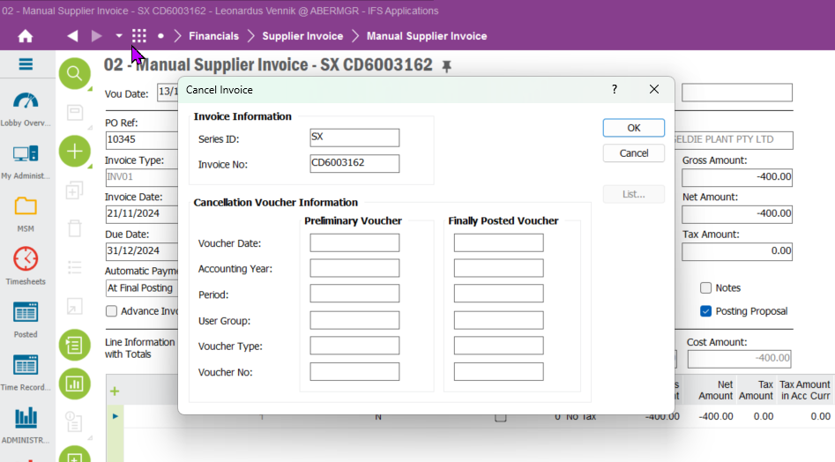

Click OK

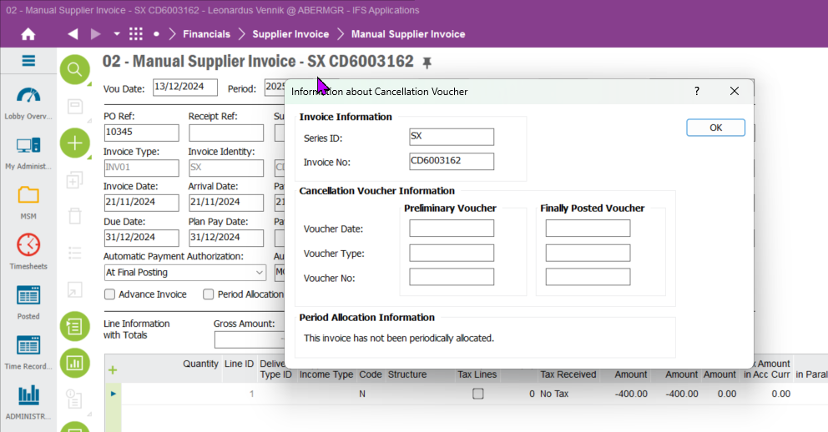

Invoice is now cancelled
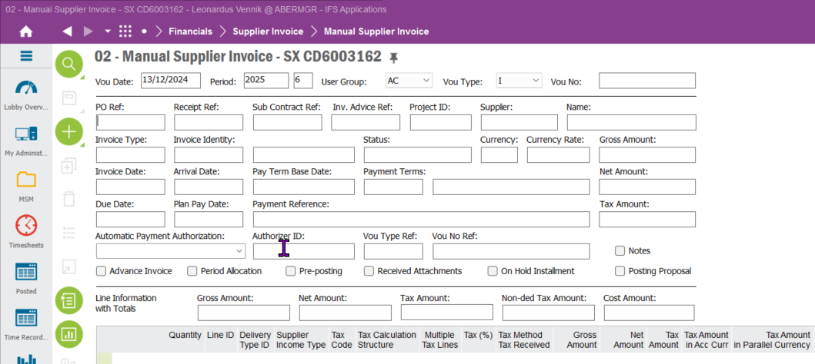

Go to Multi Company External Invoices and query for the invoice

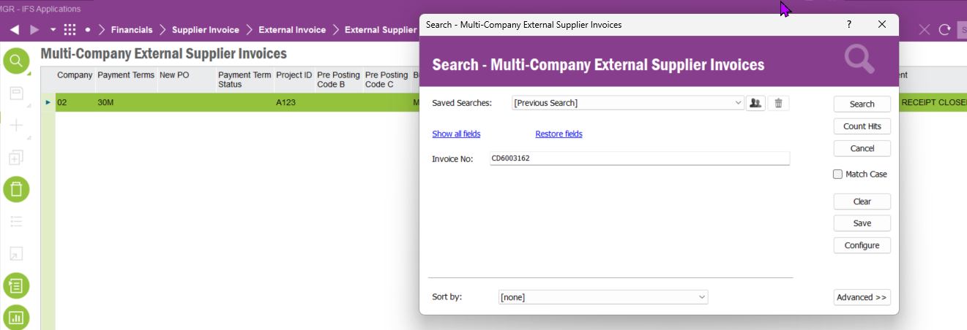

Highlight the invoice line and click Delete and save
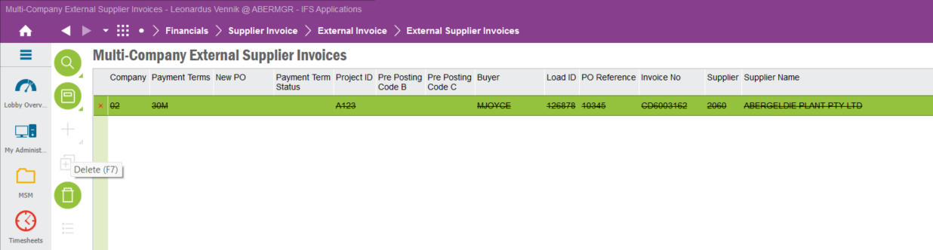

Invoice is now removed.

